**1.Taledo**

**Link**:<https://www.taledo.com/candidates?campaignid=1404001571&adgroupid=56992133722&adid=357769586525&gclid=EAIaIQobChMI1OLg0Lux9AIVbhoGAB0VJg07EAAYASAAEgK0XfD_BwE>

**about us**: We want to get you hired. Being responsible for hundreds of hires in the past, we have built a profound expertise in this area. We are well aware of the daily struggle to hire top talent – both as a candidate and as a recruiter.

Thus, our aim became to facilitate the yet-so-inefficient recruiting process: A process which is key to a company’s success! We put a lot of brainpower, time and effort into Taledo to ensure we connect the right candidates with the right companies at the right time



**2.Abc teachers**

**Link:** https://www.abc-teachers.co.uk/education-jobs?gclid=EAIaIQobChMItsrUuLyx9AIVifdRCh0AFQwrEAAYAyAAEgIsuvD_BwE

**About:** We recruit and supply teachers and other support staff for primary, secondary and SEND schools and other learning institutions across the East and West Midlands. We are always looking to recruit experienced and newly qualified teachers, teaching assistants (TAs), higher level teaching assistants (HLTAs), cover supervisors and other school support staff for day-to-day supply, short and long-term placements and permanent jobs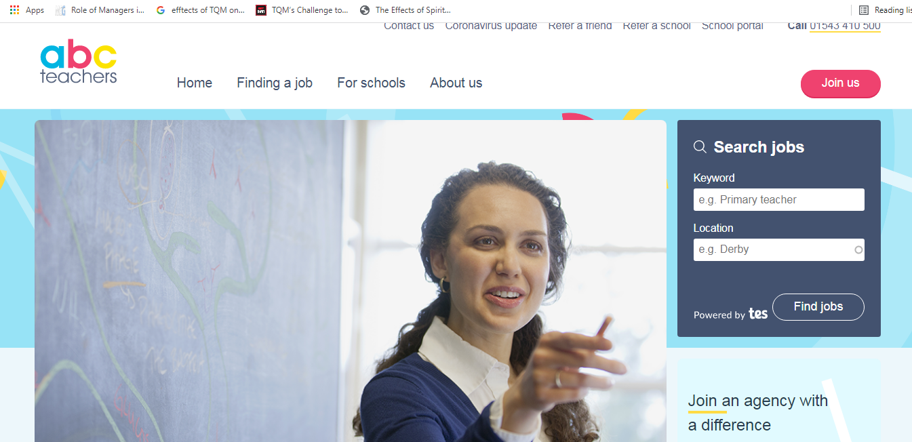

**3.Jnee**

**Link:**https://jnee.uk/gb/onboarding-software-for-small-business-jobs-in-united-kingdom?as=2&g=550&utm_source=google&utm_medium=cpc&gclid=EAIaIQobChMItsrUuLyx9AIVifdRCh0AFQwrEAAYBCAAEgI0Q_D_BwE

**About:**

Jnee is a **job search** engine launched in 2017 to assist candidates in finding ideal jobs and employers find suitable candidates. Millions of people all over the world are looking for jobs relevant to their skill and interest. Moreover, many of the employers can't find qualified candidates for their open jobs. Hence, Jnee aims to empower employment across the globe through one single platform making job search easier. It contains the database of millions of job listings and recruitments. At Jnee, we feel proud making mutually favorable matches between employers and job seekers. We make sure that each fulfills the requirements and expectation of each other. You can have information regarding **job vacancies** throughout India, USA, UK, Canada & Germany on our job portal site. Our **online job portal** will help you with latest **job alerts** from India, USA, UK, Canada & Germany. Let us help you build your career. We can achieve the goal of bridging the gap between job seekers & employers by deeply understanding the needs of our corporate clients and then using exclusive strategies to find the most appropriate job candidates. Jnee provides recruitment capabilities by identifying top level talent for employers looking for enthusiastic professionals globally.

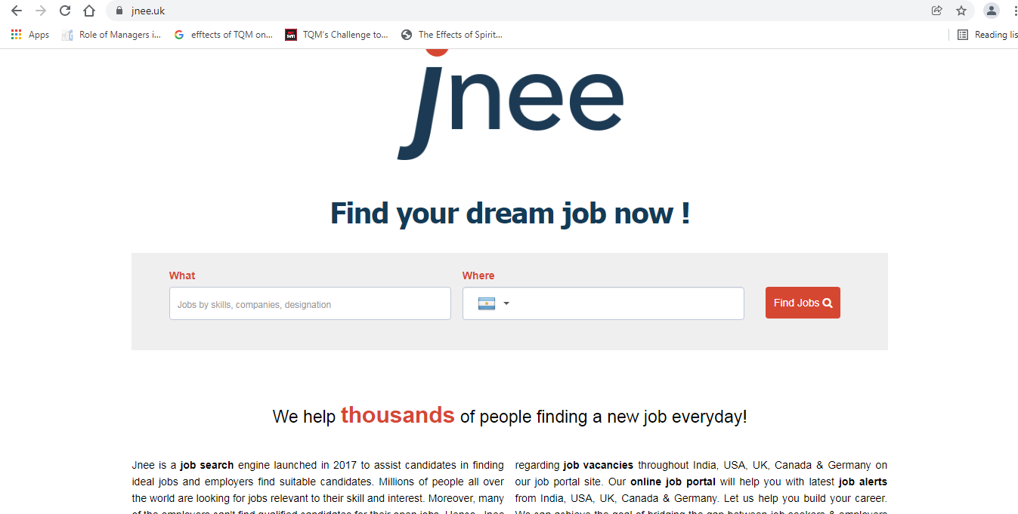

**4.HjUk**

**Link**:<https://www.hospitalityjobsuk.com/>

**About us**

**Hospitality Jobs UK is the fastest growing job board specifically for the hospitality sector.**

* Working closely with clients, big and small from hotels, pubs & bars, contract catering, casual dining, restaurants, leisure and coffee shops. We offer easy advertising solutions, raising their employer brand and giving them access to candidates.
* We are committed to continuously investing in the present and the future of our exciting industry and overcoming the challenges that it faces.
* It’s simple, we **want to ensure the best and most relevant candidates apply for your jobs** and want to take the hassle out of hiring.

**If you are looking for your perfect job -**Whether it’s a new job or career opportunity search for the best jobs across the UK for hotels, pubs & bars, contract catering, casual dining, restaurants, leisure and coffee shops, apply and search today on Hospitality Jobs UK.

**To make your job search quick and easy you can:**

* Apply quickly and save and manage your job searches
* Upload your CV so great employers can find you
* Set up job alerts to let you know any new jobs that match your skills

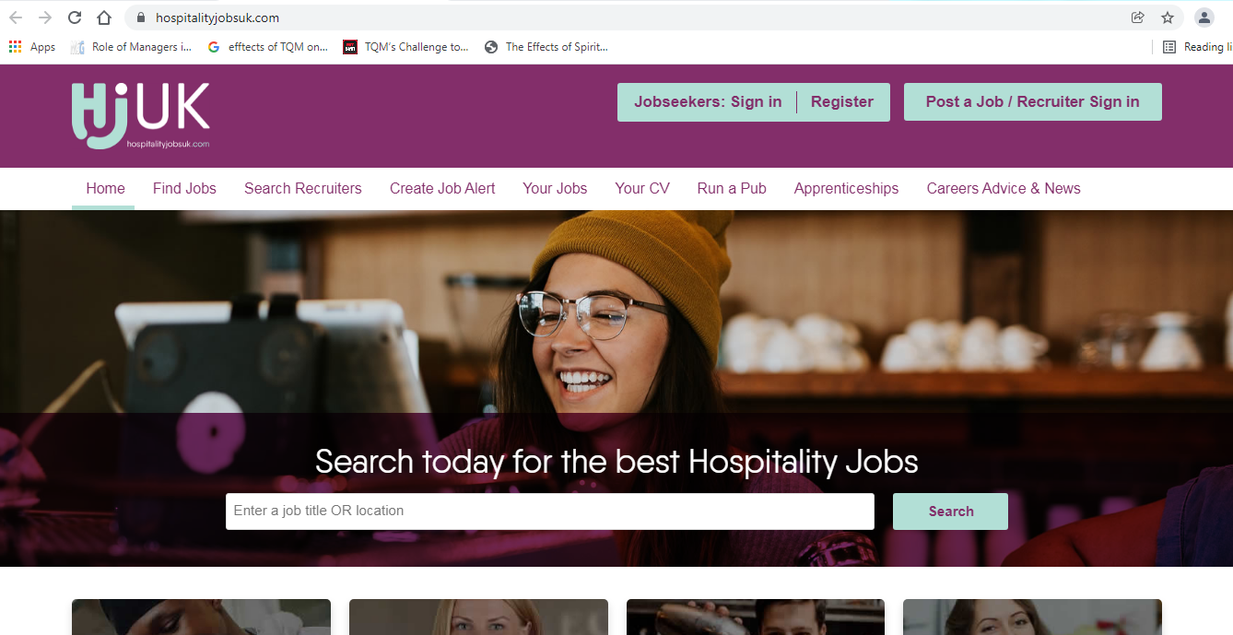

**5.Charity job**

**Link:**https://www.charityjob.co.uk/?source=nav

**About:**CharityJob connects not-for-profit organisations with the most passionate candidates in the charity sector.

**Helping charities  
to thrive**

We believe in freeing charities from high recruitment costs so they can spend their budget on making a difference.

**Finding and  
connecting talent**

We believe charities can succeed if they have the right people working for them.

**Empowering the community**

We believe in helping candidates learn more about the charity sector and helping them find the best opportunities.



**6.Pickaweb**

**Link:**<https://www.pickaweb.co.uk/>

**About The Company**

## Pickaweb is one of the UK’s first web hosting providers. We have grown to host tens of thousands of websites. Our aim is simple; to offer the service we would want ourselves - power, reliability & security but backed up by a personal level of expert service around the clock - instant, expert support when you need it.



**7.Top financial jobs**

**Link**:<https://www.topfinancialjobs.co.uk/>

# About Us

# TopFinancialJobs.co.uk is a specialist accounting, banking and finance jobs site which publishes vacancies on behalf of employers and financial recruiters in London, the United Kingdom and overseas.

Whether you are a recent graduate thinking about a career in the City of London, would like to train as an accountant or are interested in working in financial services, TopFinancialJobs will have the right financial career opportunity for you.

We also provide an extensive financial Careers Centre in which we publish quarterly financial recruitment surveys, news from the financial jobs market, answer your career related queries and offer advice on writing a successful CV and how to succeed in interviews.

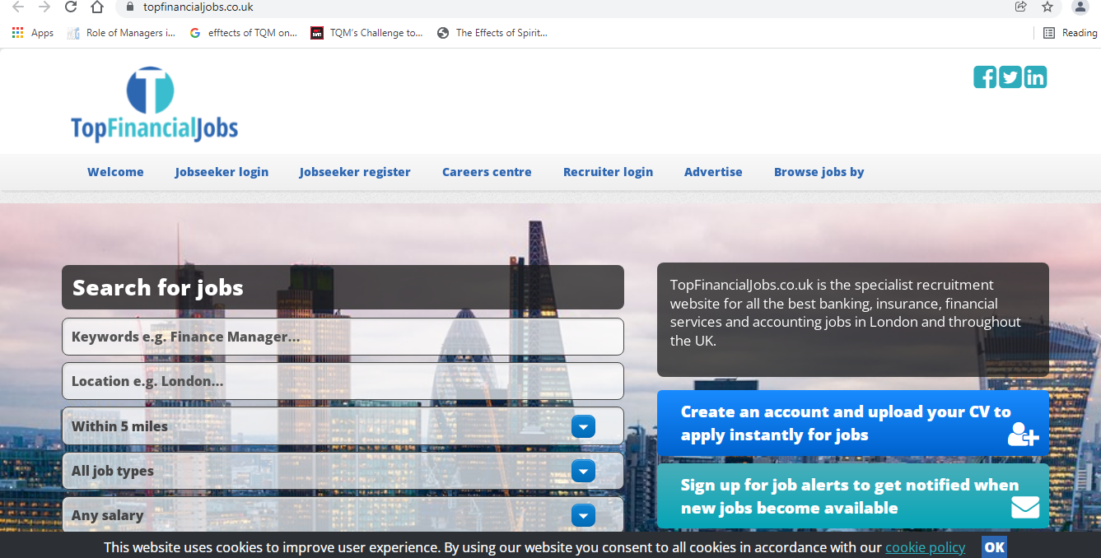

**8. NorthEastJobs**

**Link:**<https://www.northeastjobs.org.uk/>

**About :**NorthEastJobs allow jobseekers to highlight their skills and let employers know what kind of work they are looking for.

As a jobseeker you have control over which Talent Pools you wish to join, and which employers can view your profile. To join a Talent Pool, you will need to register your details on the site under My Account. You can then add information to your Talent Profile about your skills, experience and work history.

You can select one or more employers from a list on NorthEastJobs that you want to be able to view your Talent Pool profile. Your details will be kept securely for 12 months so we can match you to any similar vacancies in future. Employers may look for registered users within the Talent Pool and may choose to alert them about suitable vacancies when they arise.

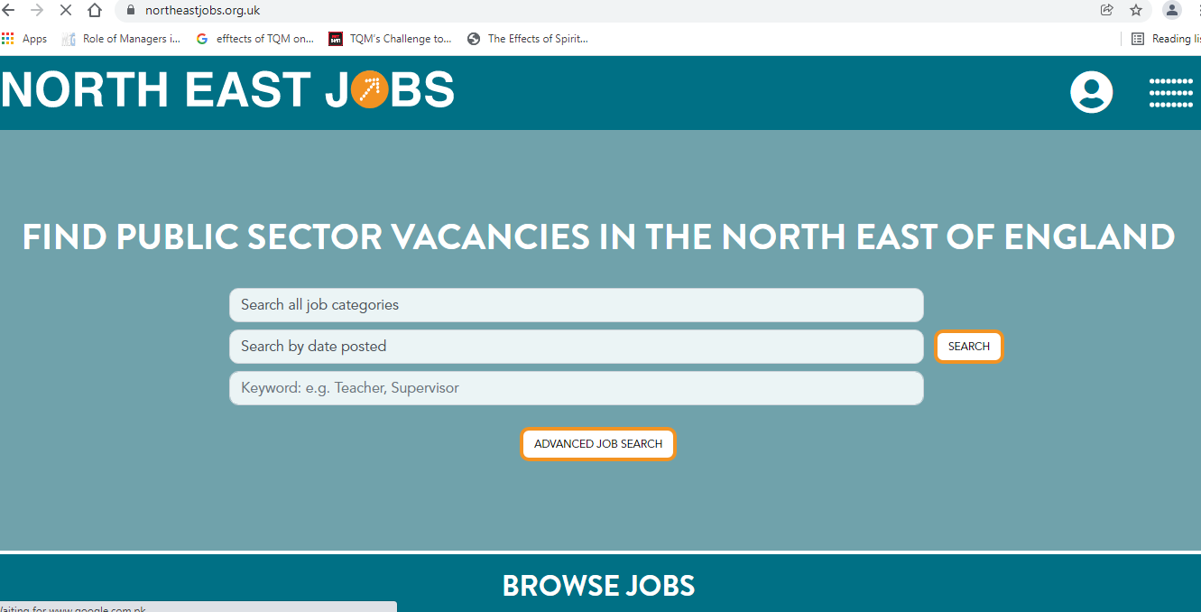

**9.wwjobs.co.uk**

**Link**:<https://www.wmjobs.co.uk/job/107857/site-services-officer/>

**About :**The new platform boasts the latest in online job advertising giving us more ways to promote our vacancies alongside a much better user experience as the new site is fully responsive to any device – e.g. mobiles, tablets etc.

There is a breadth of opportunity across the public sector – that you will be hard pushed to find anywhere else.

From highways to infrastructure to teaching to finance to legal to HR, to working with children and adults who are vulnerable, there is such a huge variety that people are often surprised by just how many roles there are and the scope for personal development within the sector.

There has never been a more exciting or challenging time to work in the public sector. There is lots of change taking place, lots of transformation and lots of challenges in delivering more high quality services with less money.

Ultimately the sector is focused on making a positive difference in our communities.

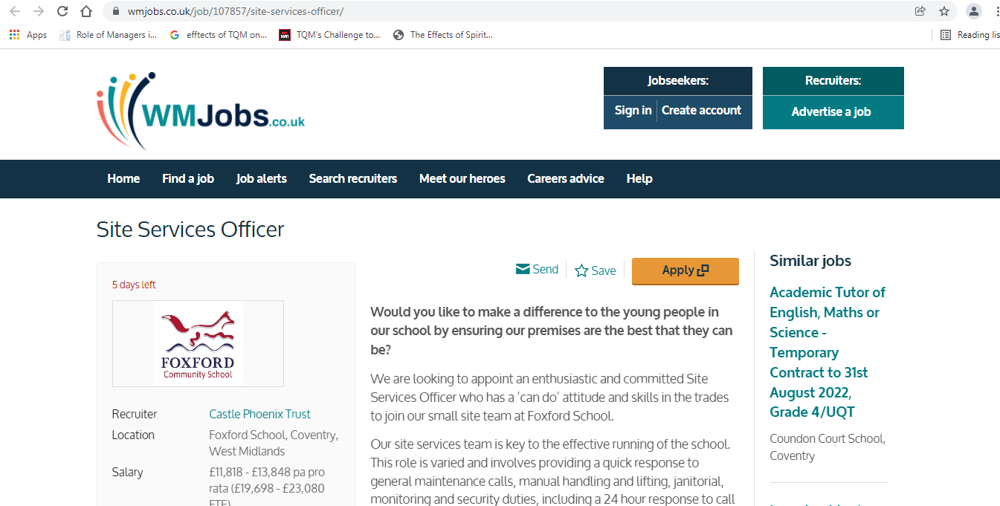

**10. GulfTalent**

**Link:**<https://www.gulftalent.com/>

**About :**GulfTalent is the leading online recruitment portal in the Middle East, used by over 10 million experienced professionals from all sectors and job categories. It serves as the primary source of both local and expatriate talent to over 10,000 of the largest employers and recruitment agencies across the region.

Founded in 2005, the company has transformed the region’s online recruitment landscape through its innovative approaches as well as its relentless obsession with quality and excellence.

GulfTalent is run by a seasoned team of young professionals with diverse backgrounds across different industries, including technology, finance, sales and recruitment. The team also brings together a wealth of international experience across four continents.

